TOURING INDIGENOUS AUSTRALIAN ART COLLECTION FOR LOAN

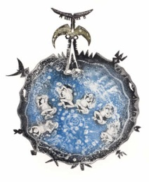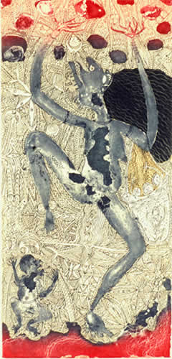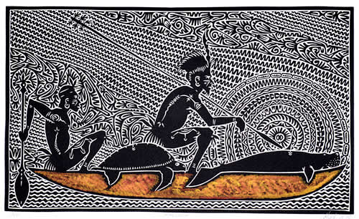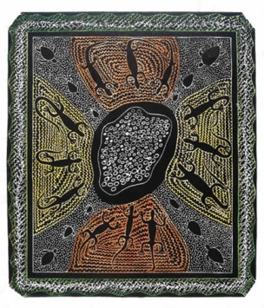

The Australian Embassy in Lisbon owns a collection of 16 artworks by contemporary Torres Strait Islands artists, which is meant to tour Portugal on a regular basis. The collection is lent free of charge for periods of up to four weeks. Any municipality, museum or art gallery interested in hosting the exhibition should contact the Embassy’s Cultural Relations through the e-mail address carmen.costa@dfat.gov.au or telephone no. 21 3101500 (Monday – Friday, 9am – 5pm).
For information on some of the artists included in the collection please consult:
http://www.youtube.com/watch?v=35clPVZ6JQM
http://www.aboriginalartresource.com/exhibitions-events/dennis-nona-new-works-by-telstra-award-winner
http://www.nma.gov.au/exhibitions/dhari_a_krar/alick_seriba_tipoti
http://artnews.com.au/details.php?e=1553
http://www.youtube.com/watch?v=c__wrZU44VU
http://www.torresnews.com.au/index.php?option=com_content&view=article&id=1489:solomon-booth-wins-gab-titui-art-award&catid=3:news

